**APPLICATON FOR LIBRARY CARD**

**Library membership is free to residents of the Municipality of Russell-Binscarth**

LAST FIRST MIDDLE

NAME: _____________________ NAME: ____________________ INITIAL(S):______

BIRTH DATE: _____ / _____ / _____ PHONE NUMBER: ______ - _______- _________

month day year

**IF UNDER 18**: Names of Parent / Guardian: (only names listed will have access to this account)

NAME: ____________________________ Name: ______________________________

last name first name last name first name

MAILING ADDRESS: _____________________ __________________ _____________

apartment, street, or PO box city postal code

HOME ADDRESS:_________________________________________________________

physical address – street / section – town - range

MUNICIPALITY YOU RESIDE IN:____________________________________________

EMAIL ADDRESS: ________________________________________________________

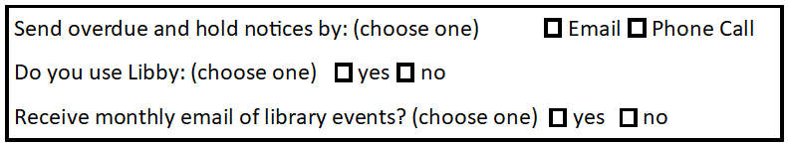

The applicant, or parent/legal guardian if applicant is under the age of 18, agrees to be responsible for all materials borrowed and to abide by the rules and regulations of the Russell & District Regional Library.

**APPLICANT SIGNATURE: ________________________________________________**

**(**If applicant under 18, parent/guardian to sign)

